**GIT HANDSON**

**Exercise – 1**

In this hands-on lab, we will learn how to

* Setup your machine with Git Configuration
* Integrate notepad++.exe to Git and make it a default editor
* Add a file to source code repository

**Step 1: Setup your machine with Git Configuration**

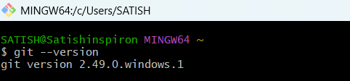

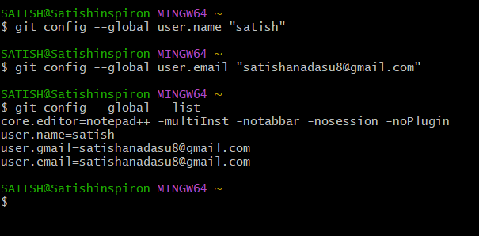

**Step 2: Integrate notepad++.exe to Git and make it a default editor**



Already i integrated notepad++

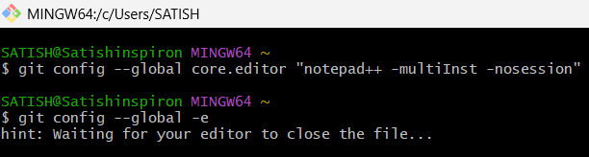

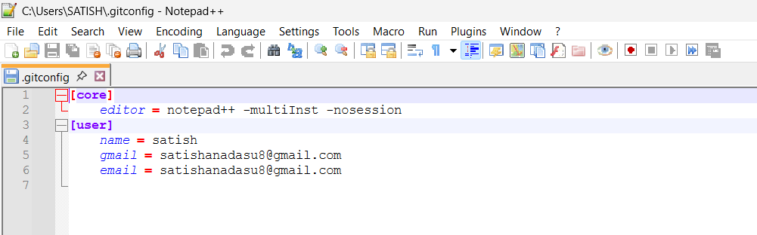

**Step 3: Add a file to source code repository**

